Physical Activity Tracker – Patient App

# Overview

Welcome to the Physical Activity Tracker User Guide. This guide is designed to help you navigate and make the most of the Physical Activity Tracker app. The guide is organized into multiple sections:

* Overview – What this app is for and key stuff to know.
* Getting Set Up – how to make your app share and behave the way you want.
* Navigating the Application – Walkthrough of how to use the application

## Introduction

The app is available for both Android and iOS devices. Being more active can have a huge impact on our health and how we feel. This app is a tool to help you become more active and stay active.

This application was developed under the guidance of the American Heart Association and other participants in the Physical Activity Alliance and is based on U.S. physical activity guidelines. It’s intended to support you in meeting your physical activity goals and allows you to track physical activity information yourself, as well as to share that information with your doctor, personal trainer, or other professionals who are helping to support you in meeting your physical activity goals.

The app will help you do several things:

* Track information about your level of physical activity, including what you do, when you do it, for how long, and how much you’re enjoying it.
* If using devices that can capture the information, also tracking information such as number of steps, heart rate, calories, etc.
* Either on your own or with the help of a care provider, setting physical activity goals and tracking how you’re doing against your goals.
* Seeing information shared with you by your care providers such as exercise plans, as well as being able to respond to requests and suggestions from your care provider electronically
* Share information between you and your care providers so they can better support your physical activity journey.
* If you’re using an Android or iOS device, share information you’ve captured with other apps through Apple Health and Health Connect.

NOTE: At all times, you remain in charge of your data. You decide what information you want to track and capture. You decide which providers (if any) to connect the app to for information sharing. You decide what information you want to share with other applications running on your device. You can also change your mind about these things and change your settings at any time.

## Legal Stuff

By using the Physical Activity Tracker app, you agree to the following: the App is not a substitute for professional medical advice, diagnosis, or treatment. It is provided "as is" without warranties of any kind, and we are not liable for any data loss or damages arising from its use. You assume all risks associated with using the App. We reserve the right to terminate your access at any time. You will not receive any compensation for using the App or providing feedback. All intellectual property rights belong to the American Heart Association. Continued use of the App indicates your acceptance of these terms. If you do not agree, please discontinue use and remove the App from your device.

## This is a Test

This application is currently in ‘beta’. This means that we’re currently testing it with patients and providers to evaluate how well it meets everyone’s needs. We believe the application is ready for use and we **want** you to use it. However, there may be some features that don’t work well on all devices or things that don’t work the way you might like them to.

First, we ask for your patience and understanding if the application misbehaves or is harder than it should be. Second, we ask for your feedback. Please tell us what doesn’t work or what could work better. What would make this application more useful in helping **you** to be more active?

Because this application is ‘in testing’, it’s possible there will be some issues or desired features we already know about. We’ll maintain a list of known issues and limitations here. Please look at this list before reporting an issue (though if you want to add your vote asking for a new feature, feel free.)

Feedback can be submitted here.

We will take what we learn from your feedback and work to make the application better.

# Getting Set Up

The welcome screen is the first screen that appears after launching the application. It gives a short explanation of the application, asks you to accept our license, and then gives you the option of “setting up” the application.

While you can skip the set-up step and dive right in, we encourage you to go through the set-up wizard as it will make the application more useful for you. The specific steps it will walk you through are:

* Connecting with providers
* Syncing with Other Applications
* Deciding what to track

If you “skip” performing any of these steps, you can come back to them using the “Configuration” menu option later. You can also use the configuration menu to make changes to your settings later if something changes.

## Connecting with providers

This application is intended to allow you to share information with doctors, personal trainers, and other people who can help you to be more active. Being able to see what activities you’re doing and how well they’re working for you allows them to support you better. As well, the application provides an easy way for you to see the goals and plans you’ve agreed to with them, and to see any other instructions or requests they might have for you.

NOTE: Not all providers will be set up to be able to share information with this app. Providers need to have a computer system that knows how to handle this information and how to talk with this app. During this testing period, you’ll likely only be able to share information with the specific providers who suggested you start using this app. If you know other providers who have said they would also like to be able to see this information, have them send an email to [need to decide what that is] and we can provide information about getting involved in the test, or in using the system after the test.

Even if a provider’s system can’t connect directly, you can always bring your phone or other device when you visit them and show them your progress.

### Health Provider Intro

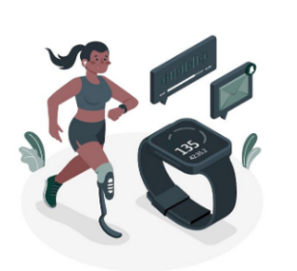Setting up the connection with your health provider allows the app to send your activity data directly to your provider's system. This can help in more accurate monitoring and management of your health and fitness goals.

If you decide to set up the connection later (‘skip’), you can still use the app to track your activities, but syncing data with your provider will be delayed until the setup is complete.

### Connect to Your Health Provider

This screen sets up the connection between your Physical Activity Tracker app and your health provider's system.

There are two ways to connect to your health provider:

* **QR Code Scanning**: In most cases, your health provider will have given you a piece of paper or a card with a special picture that looks like the one on the right (don’t use the one printed here as it won’t work). If you have one of these, click on "Tap to scan" and point your device's camera at the QR code. This method is quick and ensures that the connection details are accurately entered.
* **Manual Connection**: If you do not have a QR code, there is an option to connect manually. You will need to know the health provider's connection URL and client ID. This information should be provided by your health provider. Click on “Please select connection” and type 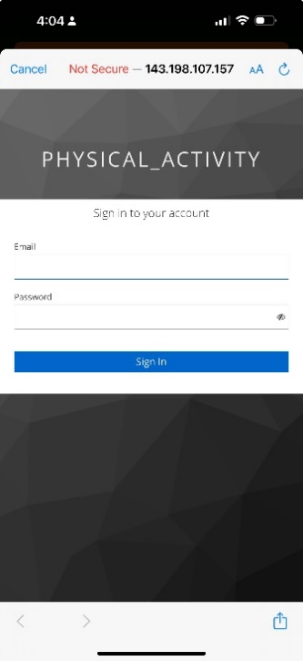the information when prompted.

After clicking the "Connect" button, you will be taken to the login screen for the Physical Activity FHIR server where you will need to enter your email address and password.

*Note: Your clinic, gym or other organization will set up your login details to connect to their system. Make sure you have received your login details before attempting to connect. If you encounter any issues, please contact the staff at your health provider for assistance.*

### Multiple Connections [Optional]

Once successfully connected to the FHIR server, you will have the option to connect to another health provider. For example, you might want to share information with your primary doctor, your cardiologist, and your personal trainer. Provided that all of these providers have systems that are able to connect, you can enable sharing with all of them.

If this is not applicable to you, select 'No'. Otherwise, you will go through the previous steps again – once for each provider you wish to connect with.

*Selecting Primary Connection:*

If you have connected to multiple providers, you may need to "Select Primary Connection". This will be the place where your goals, plans and other information will be managed. (The app doesn’t allow that information to be updated in different places because it can get out of sync.)

## Syncing with Other Applications

If you are using a more recent Android or iOS phone or tablet, your device has a built-in secure storage area for sharing your health information between apps – and sometimes with your health providers. You need to give permission for apps to put information in that secure area as well as to get information from it.

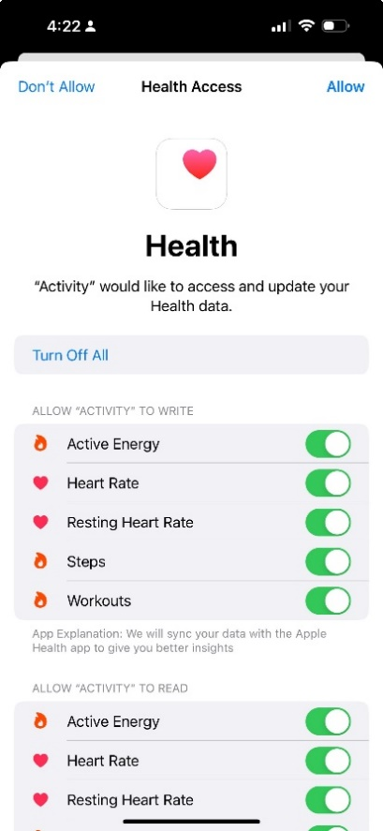There are several reasons why you might want to enable application synching:

* Devices such as Fitbit, or even your phone itself may capture heart rate, steps, or other information that would be useful to be available in the Physical Activity Tracker app.
* You might wish to enter certain information in a different app (e.g. one that better tracks the types of workouts you typically do) but still have it available as part of your physical activity tracking.
* You might want information you capture in your physical activity app to be visible in a lifestyle app (e.g. one that allows you to compete with or compare with friends)
* Some providers have an ability to access certain information from your device if you give them permission.

The steps to enable syncing are:

* 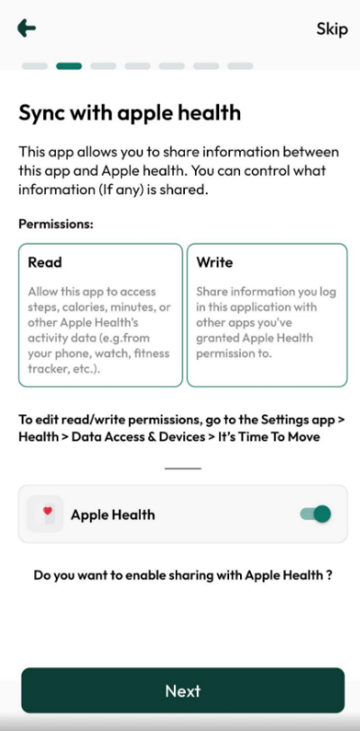*Permission Request*: The screen requests permission to read and/or write health data to and from Apple Health/Health Connect. This includes data on active energy, heart rate, resting heart rate, steps, and workouts. These are the types of information this app can capture and make use of. “Write” permissions indicate what the Physical Activity Tracker can share with other apps. “Read” permissions indicate what the Physical Activity Tracker can get from other apps.
  + - *Control Over Data Sharing*: You can control what information is shared by toggling the permissions. This ensures that only the data you are comfortable sharing is synced with Apple Health/Health Connect. In most cases, you’ll choose “Turn On All”, but if there is some information you don’t feel ok sharing, adjust the switches to what feels best.
* *Enable Sharin*g: Click "Yes" to enable sharing with Apple Health or Google Fit, or "Skip" to proceed without syncing.

NOTE: If you opt to enable sharing, the app will import data already stored on your device. This may take several minutes, depending on how much information already exists on your phone or tablet.

## Deciding what to track

The Physical Activity Tracker app allows you to capture a lot of different types of information. However, you might only be interested in tracking a smaller amount. The app allows you to configure what types of information you’re interested in so that screens only ask for and show you the things you care about (and have tools to be able to capture).

For example, you might have an exercise bike that will report calories burned for a ride. You might then turn that on for biking and have a place to record that number. However, when you run, you might only be able to capture how long your run was and not want to see ‘calories’ as an entry on your screen.

In addition to choosing what to measure, the app allows you to configure what types of activities you want to track (and to define some of your own). By de-selecting the types of activities you never engage in, your selection menus will be shorter, making it faster to record your activities.

### Configuration Intro (Personalized Tracker)

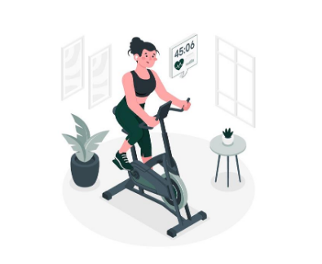The Configuration Intro Screen provides an overview of how to set up and manage your activities within the app. You have the option to proceed by clicking "Yes" or skip the setup by clicking "Skip".

### Activity Selection

In the Activity Selection Screen, you can “turn off” activities you don’t generally use, add new activities, and modify the tracking settings of those that aren’t “turned off”.

Adding a New Activity:

1. Click the plus button.
2. Select the activity name and images from the drop-down list. If Apple Health has data for the selected activity, it will be synced automatically (Note: custom activities will be mapped/synced to ‘Other’).

This screen allows you to personalize the activities tracked by the app, ensuring it meets your specific needs and preferences.

### A screenshot of a phone Description automatically generatedTracking Preferences

The Tracking Preference Screen allows you to select which data you want the app to track. You can enable or disable tracking for various measures such as total minutes, moderate minutes, vigorous minutes, notes, strength days, calories, steps, resting heart rate, peak heart rate, and experience. Additionally, you can change the order of these measures by dragging and dropping them according to your preference. If you’re going to be entering information from a treadmill, bike or other device, it may be helpful to have the data values listed in the same order they are on your equipment.

## Goal Configuration

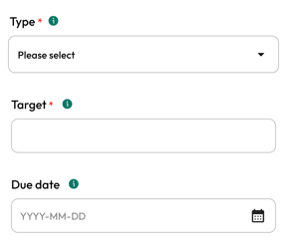The Goal create screen allows you to create specific goals such as the number of steps, calories burned, or exercise duration. Each goal can be tailored with a target, due date, and notes. This screen also allows you to monitor the lifecycle status of each goal, indicating its current progress and state.

# Navigating the Application

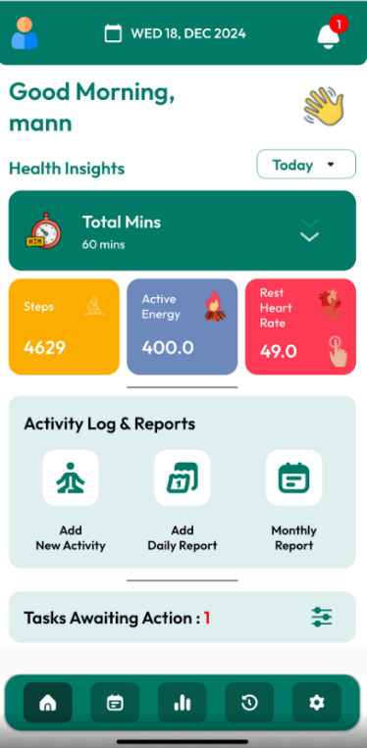The Physical Activity Tracker has a menu of 5 buttons across the bottom of all the app screens. These will navigate you to the following screens:

* Home
* Tracking Chart
* Graphs
* Plans and Goals and
* Settings

## Home

The Home Screen serves as the starting point for the Physical Activity Tracker app. It gives quick access to all major features, such as logging new activities, daily logs and monthly summaries, and accessing tracking charts and to-do lists.

Features include:

### New Activity

|  |  |
| --- | --- |
|  | The New Activity feature allows you to record a period of physical activity you have completed. You can enter details such as the date, type of activity, duration, calories, steps, heart rate and experience (how much you liked it). While your phone and other devices may be able to detect and capture certain activities and measurements, this screen allows you to capture the full set of details. Information captured here is then used to help calculate daily and monthly values.  If you need to add another activity type or another measure you want to track, you can click on the configuration icon (on right-side) to configure those again. This feature allows you to customize your activity tracking to better suit your needs. |

### Daily Values

|  |  |
| --- | --- |
|  | Daily Values enable you to log and monitor your physical activity on a day-by-day basis. This is where you capture information that is not tied to a specific period of physical activity, but instead represents a daily total or maximum. For example, daily steps, daily calories, average resting heart rate, or peak heart rate. You can also use this screen to enter total minutes of physical activity for the day, perhaps to reflect exercise you did on days where you didn’t capture individual activities.  Information gathered on this screen can be used to help measure progress towards your goals, or just to get a better sense of your overall level of physical activity and fitness. |

### Monthly Summary

The Monthly Summary provides an in-depth overview of your physical activity over the month, focusing on four indicators. These indicators are based on guidelines set by the U.S. Department of Health and Human Services. They help you understand your exercise habits and overall fitness progress:

* *For an average week in the last 30 days, how many days per week did you engage in moderate to vigorous exercise (like walking fast, running, jogging, dancing, swimming, biking, or other activities that cause a light or heavy sweat)?*
* *On those days that you engage in moderate to vigorous exercise, how many minutes, on average, do you exercise?*
* *The product of the two Exercise Vital Sign (EVS) measures, giving an average amount of moderate to vigorous physical activity in minutes/week*
* *An indication of the frequency of strength-based exercises a patient has performed, expressed as days/week*

These indicators are auto calculated from the data entered at the daily or weekly level through the Tracking Chart. However, if you wish to override the auto-calculated measures, you can do so. Making manual adjustments will not affect the calculations at the weekly or daily level, allowing for flexibility in how you track and report your activity.

### To-Do List

The To-Do List helps you manage requests from the providers you’ve ‘connected’ your app with related to your physical activity. It includes tasks that need your attention, such as a request to look at a particular web page, watch a video, contact a particular provider, or some other A screenshot of a phone
instruction. You can mark a task as ‘completed’, ‘in-progress’, ‘on-hold’, etc.

The screen allows you to see your open tasks, update the ones that are complete, add comments, or in some cases, indicate that you can’t or don’t want to perform a requested action. This ‘task’ mechanism allows you and your providers to interact without you necessarily having to come in for a visit.

By default, only tasks needing your attention are displayed. However, if you click on the 'Show all' button at the bottom of the form, you can see older tasks you’ve performed or refused.

## Tracking Chart

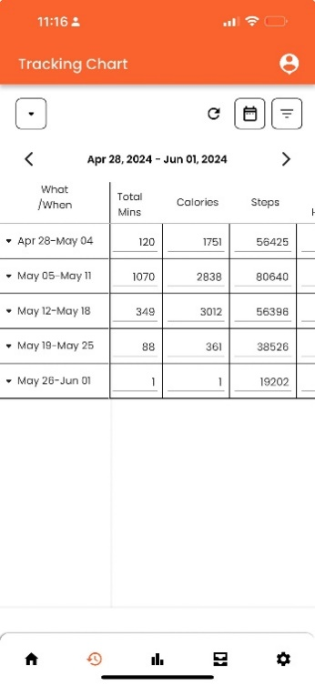The Tracking Chart visualizes your physical activity data, allowing you to see your progress over different periods (daily, weekly, monthly) and for different activities. The chart is designed to provide an overview of your activity for the last 30 days, displayed in a five-week format. By default, it opens the current week. It includes various measures such as total minutes, calories burned, steps taken, and heart rate, depending on what you have configured in the initial setup.

Key features of the Tracking Chart include:

* **Data Levels**: Each measure can be tracked at the activity, daily, and weekly levels. The chart auto-calculates values at higher levels based on the entries at lower levels. If the top-level value does not match the auto-calculated values, a pop-up will ask if you want to enable auto-calculation or rely on the manual values.
* **Navigation and Filters**:
  + *Left Filter*: Allows you to expand/collapse the weeks and days level entries or hide empty rows.
  + *Right Calendar Button*: Allows you to navigate to other weeks/months.
  + *Right Filter Button*: Lets you hide column measures that you do not want to record.
  + *Week Slider*: Located at the top, it lets you scroll to previous and future five weeks.

## Graphs

The Graphs screen offers a complete view of your physical activity data in a graph format. It allows you to assess your progress over time and compare your activity levels across different periods.

Graphs can be plotted for any of the measures, including:

* Activity minutes (Total, Moderate, and Vigorous minutes)
* Heart rate (Rest and Peak)
* Calories burned
* Steps taken
* Experience

You can plot these graphs at the day-level or week-level, allowing for detailed analysis of your activity patterns. In terms of timeframe, you can view data from the last week, 4 weeks, 3 months, 6 months, 1 year, and lifetime.

Other features include:

* *Zoom-In*: Allows you to focus on specific time periods or data points for a closer look.
* *Tooltips*: Provides detailed information when you hover over data points on the graph.
* *Multi-Line Graphs*: Enables you to plot multiple measures on the same graph for comparison.
  + *Legends*: Explains the lines on the graph, helping you understand what each line represents.

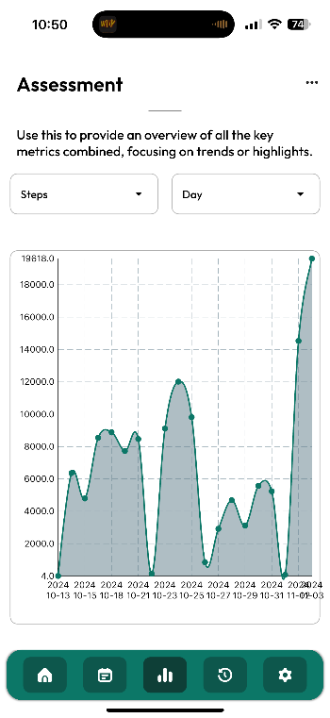 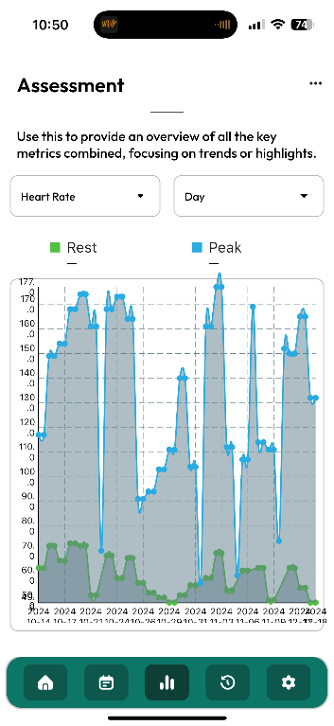 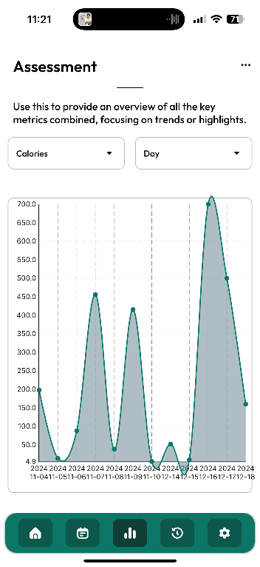

## Plans and Goals

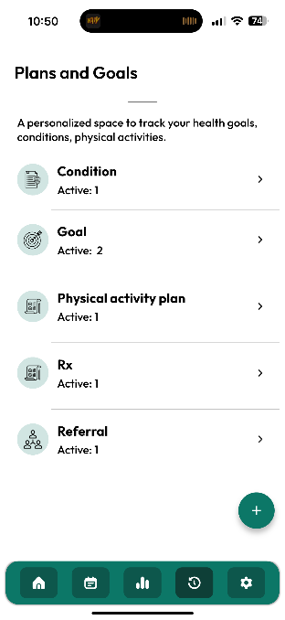The Plans and Goals screen is primarily for viewing data shared with you from the providers supporting your physical activity journey. Most of this content will only exist if

1. you are connected to one or more provider systems, and
2. your provider has created and shared relevant records with you

The only exception to this is ‘Goals’, which you can create and manage yourself, as well as providing updates and feedback about goals entered by your provider(s).

**IMPORTANT NOTE**

Several of these screens allow you to make comments to provide feedback to your provider(s) about how things are going. However, there is no guarantee that anyone will look at these notes until your next visit (and perhaps not even then). If you have any urgent concerns about your health, it’s important that you reach out to your doctor or other providers in other ways – e.g. by phone or email, or in the case of a medical emergency, by dialing 911.

### Condition

The Condition list displays health conditions that are in some way related to your physical activity. Conditions are always entered and maintained by a provider. You can review this list to ensure it is accurate. This list may be helpful to other providers managing your care, as it may impact the advice they provide around physical activity. The fact you have certain conditions may also allow other providers aiding in your care to bill some of their services to your insurance.

### Goal

The Goal section allows you to create, view, and manage personal goals related to your physical activity. It also allows you to see goals entered by your providers. Having a shared view of your goals (as well as the ability to comment on how things are going) ensures everyone supporting you is on the same page.

This page allows you to create new goals, edit goals you have created, and update the status or add notes for goals created by your provider.

### Physical Activity Plan

You are likely using this application because you want to change your level or types of physical activity in some way. Having a plan for what you’re going to do that has been agreed on by you and your providers is a great step in making those changes. Having a share plan that you can track against ensures that you know what to do now as well as where things are headed. That same shared plan allows your providers to tailor their advice and support to you based on where you are now and where you’re trying to get to.

The plan itself is managed by your providers, but you can add comments to share your thoughts on what’s working, what’s not, and whether you feel changes should be made.

### Exercise Prescription

Just as your doctor might prescribe you a medication or order a lab test to help you manage your health, they can also ‘prescribe’ physical activity – and following such a prescription can have just as big an effect on how you feel.

This part of the app lets you see what your current “exercise prescription” is from your provider. This won’t be as detailed as your exercise plan, but instead sets out what your provider believes you should be trying to do right now to get or stay as healthy as possible.

### Referral

Sometimes your primary care provider may decide that you could use the help of other providers to support you in your physical activity journey. This might include physiotherapy, a consultation with a personal trainer, a set of classes at a local fitness centre, or some other form of assistance.

Requesting this additional support is called a ‘referral’. The Physical Activity Tracker app shows you what referrals exist, who they’ve been assigned to, and what status they have. This helps keep you in the loop with respect to your care.

## Settings

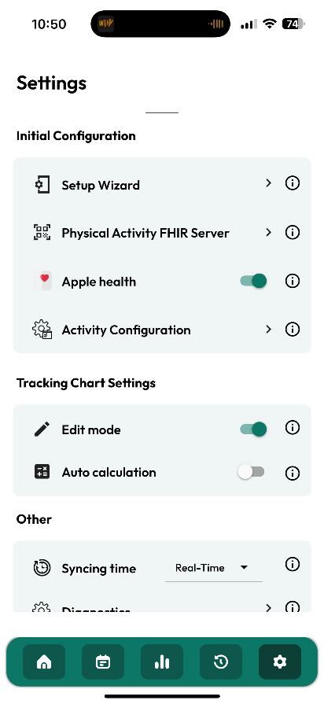The Settings Screen allows you to customize the app's functionality to suit your needs. It includes options for initial configuration, tracking chart settings, synchronization, and diagnostics.

### Initial Configuration

The Initial Configuration section helps you set up and manage the core functionalities of the app. This section includes:

* *Setup Wizard*: Guides you through the initial setup process, ensuring all necessary configurations are made.
* *Connect to Your Health Provider*: Connect the app to your health provider connection screen if any changes need to be made.
* *Apple Health*: Allows the app to sync with Apple Health.
* *Activity Configuration*: Lets you customize which activities and measures to track.

These steps are fully described in the Getting Set Up portion of this guide.

### Tracking Chart Setting

The Tracking Chart Setting section allows you to manage how your tracking data is displayed and calculated. You can enable or disable edit mode. If turned off, you won’t be able to make changes to the data when looking at the tracking chart, but only by managing your individual activities and daily values. This will keep you from making changes that might disagree with the daily values but may be less efficient than editing directly in the tracking chart.

### Synchronization

The Synchronization section lets you control how often your data is synced with your health provider. You can choose to sync data in real-time, daily, or weekly. Your provider may provide instructions on the frequency that will work best for their system.

### Diagnostics

The Diagnostics section is designed for troubleshooting and debugging purposes. If you report an issue with the app, we may reach out to you and ask you to share some of the information found on this screen.

### Send us Feedback

Send Us Feedback enables users to provide comments and suggestions about the provider and patient app. This opens a feedback form to fill out the details.

# Sync capabilities & known limitations:

## Apple Health - Understanding how Sync works

When you enable syncing with Apple Health, the app initially performs a full sync, pulling all available data such as calories, heart rate (peak and resting), steps, and activity-level data (activity name, calories and activity duration) from Apple Health. After this initial sync, the app will begin syncing data with the connected provider server. It's important to note that the app will only sync data for the currently opened month to optimize performance.

As you scroll through different months in the app, synchronization will be triggered for those months, ensuring that your provider's server has the most recent data for the periods you are viewing. This approach allows the app to maintain high performance while ensuring your health provider has access to the necessary data.

By understanding this synchronization process, you can ensure that your activity data is accurately reflected both in the patient app and in your provider's app, allowing for better health management and tracking.

**Other Considerations and Assumptions**

When working with Apple Health data, there are a few important considerations and assumptions to keep in mind:

* Data Updates: Apple Health does not allow direct updates to existing data. Instead, any update operation involves a process where the data is deleted, and new data is added. However, this method is not applicable to activity-level data.
* Activity-Level Data: Activity-level data pulled from Apple Health cannot be edited or deleted. This limitation is due to Apple's restrictions on deleting activity-level data, ensuring the integrity and consistency of the data within Apple Health. However, it is to be noted that activity-level data added from Physical Activity Tracker app is pushed to Apple Health and can also be updated.

## Health Connect - Understanding how Synchronization works

When syncing with Google Fit, only certain types of data will be synced, i.e. calories, steps, peak heart rate, and activity-level data (activity name and duration). After the initial Google Fit sync, the app will begin syncing data with the connected provider server.

* Activity-Level Data: Data will be pulled from Google Fit, including activity name and duration. Additionally, data will be pushed from our app to Google Fit, but only the activity name and total minutes. Calories will not be pushed for activity-level data, possibly due to the Android algorithms calculating calories based on duration and activity type, or to avoid unreal data.

For some reason, Google Fit is not syncing old data (older than one month) at any level (day or activity-level). Our conclusion is that this issue most likely originates from Google Fit, whether due to permissions or the way their algorithm works, as this functionality is working with Apple Health *[This is still under investigation]*.

Similar to Apple Health, we won't be able to edit data that is being pulled from Google Fit.